
Coreform ITEM Wizard Knuckle Tutorial

Tutorial Overview
This tutorial walks through how to mesh a more complex part in Coreform Cubit using the ITEM Wizard workflow. Starting from an imported model, the tutorial guides the user through setting up the FEA model, preparing the geometry, resolving small-feature issues, decomposing the model into meshable topology, generating the mesh, and validating mesh quality.
The main focus is on using the ITEM Wizard to diagnose geometry problems and apply recommended fixes, including removing a small surface feature, marking an over-detected surface as acceptable, and executing several webcut operations to make the volume meshable. By the end of the tutorial, the user will have successfully meshed the full model and checked the mesh using the Scaled Jacobian quality metric.
This tutorial is intended for users who are already familiar with basic Cubit navigation but are learning how to use the ITEM Wizard for more advanced geometry preparation and meshing workflows. The final result is a completed mesh on the full part, with quality validation confirming that no bad elements are present.

Before You Begin: Import the Model
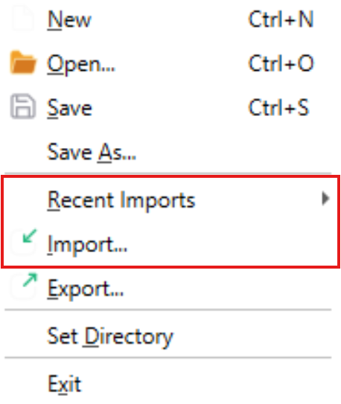
Import the model knuckle.sat from your drive or select it from Recent Imports in the file menu. Also ensure that your import options match the image below.

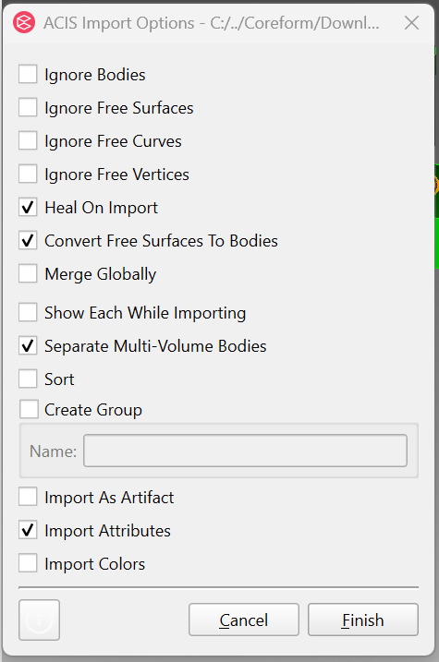

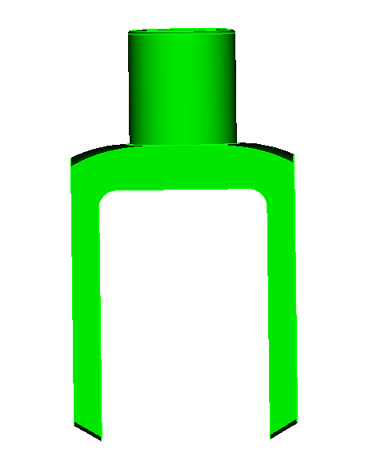

Step 1: Set Up the FEA Model Defaults
After importing the model, open the ITEM Wizard from the Power Tools panel. The first thing to do is set the default options for the wizard.
Go to Setup the FEA model, then choose Set defaults. This applies Cubit’s standard starting settings for the model so you can continue through the ITEM Wizard workflow without manually changing each setup option.
Once the defaults are set, scroll down and click Done.
Checkpoint:
You should now be back at the main ITEM Wizard page and ready to start preparing the geometry. This matches the instruction sheet sequence: import the model, go to ITEM Wizard, select Setup the FEA model, choose Set defaults, then click Done.
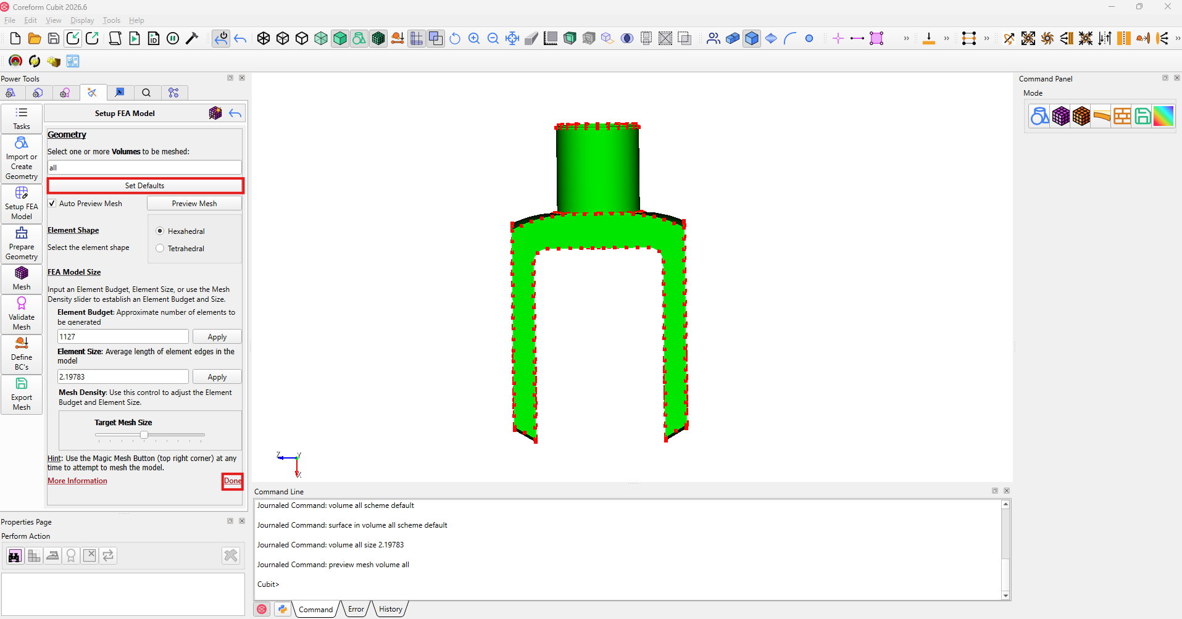
Step 2: Open Prepare Geometry
After setting the ITEM Wizard defaults and clicking Done, return to the main ITEM Wizard page. From there, select Prepare Geometry.
This section is where Cubit checks the model for geometry issues that may need to be fixed before the part can be meshed. Do not remove anything yet. For this step, you are only opening the Prepare Geometry tools so you can begin the diagnostic process.
Once Prepare Geometry is open, you should see the option for Run checked diagnostics.
Checkpoint:
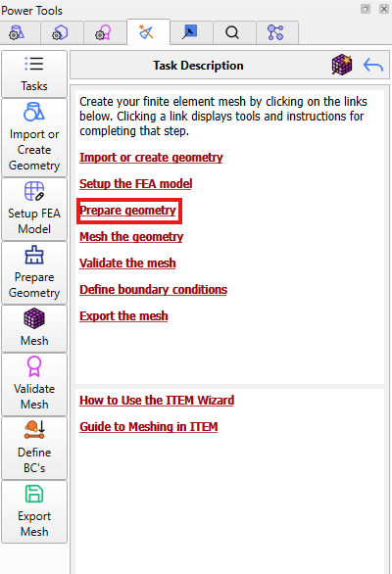
You should now be inside the Prepare Geometry section with Run checked diagnostics visible. The next step will be running the diagnostics to find small features in the model.

Step 3: Run Checked Diagnostics
Once you are in the Prepare Geometry section, select Run checked diagnostics. Cubit will scan the model and check for geometry problems that could make the part difficult or impossible to mesh.
After the diagnostic check runs, Cubit should report that the model contains small features that need to be reviewed before meshing. In the checklist, select Remove small features, then click Detect small features.
This step is not where you remove anything yet. The goal is to have Cubit identify the small surfaces that need attention so they can be reviewed in the next step.
Checkpoint:
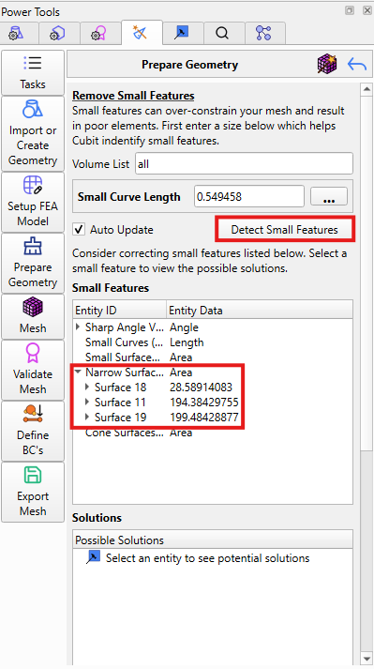
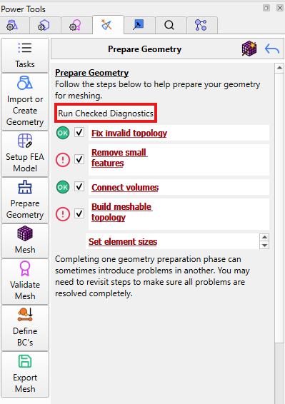
Cubit should now show results under the small features section. You should be ready to expand Narrow Surfaces and review the listed surfaces, including Surfaces 18, 11, and 19.

Step 4: Review and Fix the Narrow Surfaces
After detecting the small features, expand the Narrow Surfaces category in the Small Features list. You should see Surface 18, Surface 11, and Surface 19 listed.
Start by selecting Surface 18. Then go to the Possible Solutions section. Right click Remove surface 18 and select Execute, or select the Execute button below the Solutions tab. This removes the small ring around the neck of the knuckle.
After Surface 18 is removed, check the Narrow Surfaces list again. Surface 11 should no longer need a separate fix. Do not remove Surface 11 manually.
Next, select Surface 19. Cubit may still list this surface, but it does not need to be removed. Right click Surface 19 in the Small Features list and select Mark as OK.
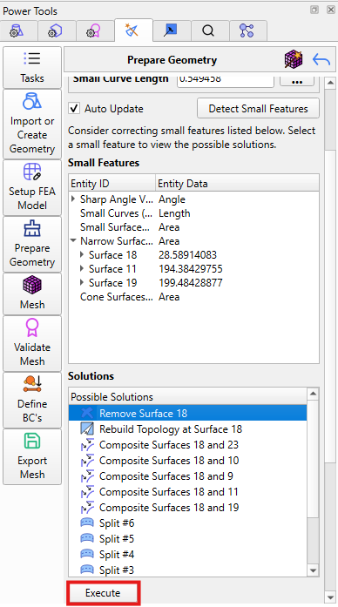
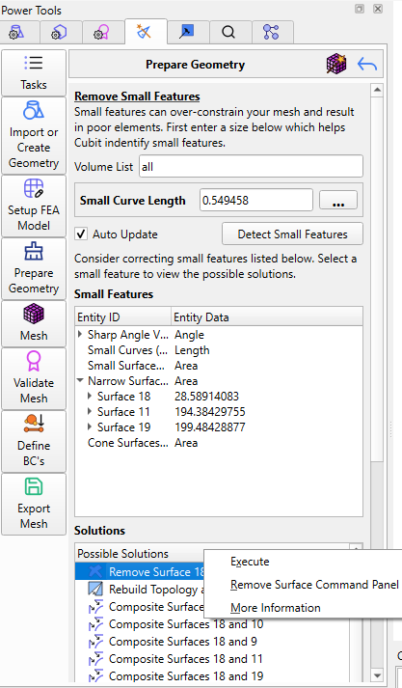
Once Surface 18 has been removed, Surface 11 has been checked, and Surface 19 has been marked as OK, scroll down and click Done.
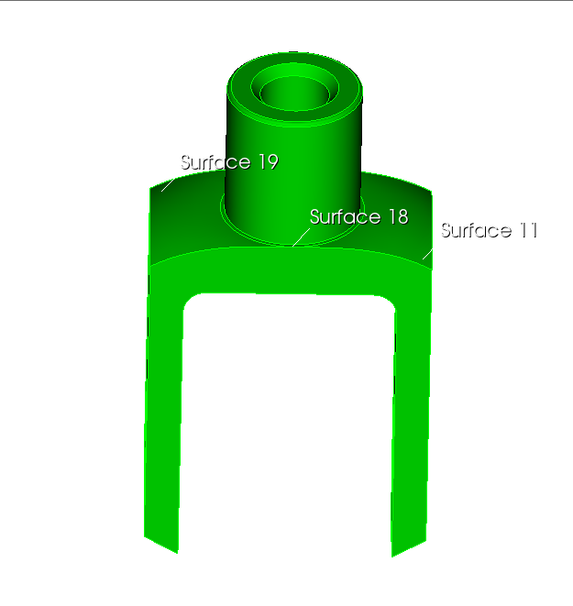

Step 5: Open Build Meshable Topology
After finishing the narrow surface fixes, click Done to return to the Prepare Geometry section. From there, open Build meshable topology.
This part of the ITEM Wizard is used to split the model into sections that Cubit can mesh more easily. Do not start cutting the model yet. For this step, you are only moving into the Build meshable topology tools.
Once the Build meshable topology section is open, scroll down until you see Decompose volume. This is the tool you will use in the next step to check whether the current volume is meshable.
Checkpoint:
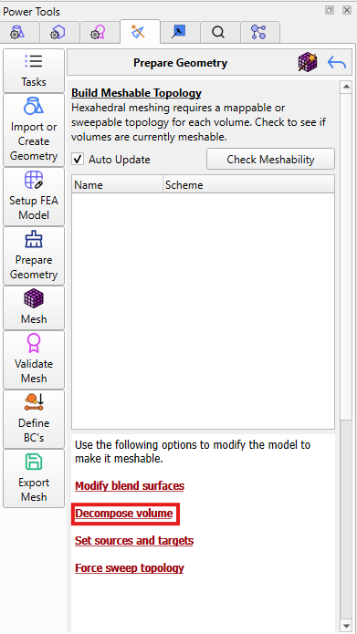
You should now be in the Build meshable topology section, and Decompose volume should be visible. The next step will be selecting Decompose volume and running Check meshability.

Step 6: Check Meshability
In the Build meshable topology section, select Decompose volume. This is where Cubit checks whether the current model can be meshed in its present form.
Click Check meshability. Cubit will analyze the model and display the results in the table below. Expand the Not meshable category, then select Volume 1.
Once Volume 1 is selected, Cubit will show a list of possible solutions that can be used to make the part meshable. Do not execute any webcuts yet. This step is only for checking the volume and opening the list of suggested fixes.
Checkpoint:
Volume 1 should be listed under Not meshable, and the possible solutions should now be visible. The next step will begin applying the recommended webcuts.
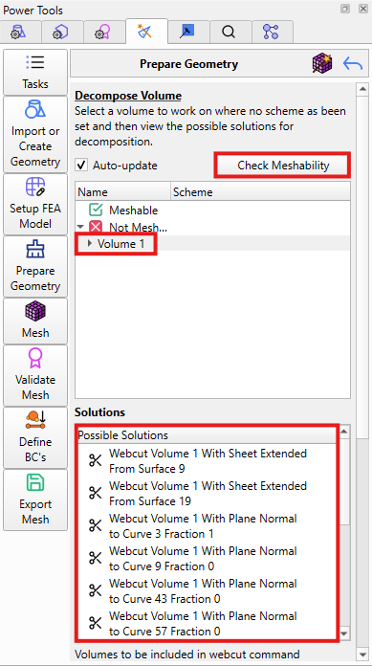

Step 7: Execute the Webcut Solutions
With Volume 1 selected under Not meshable, Cubit will show several possible solutions. These webcuts split the part into smaller sections so the volume can become meshable.
Execute the webcuts in this order:
- Webcut Volume 1 with plane normal to curve 33 fraction 1
- Webcut Volume 1 with plane normal to curve 35 fraction 1
- Webcut Volume 1 with plane normal to curve 60 fraction 1
- Webcut Volume 1 with sheet extended from surface 48
- Webcut Volume 1 with plane normal to curve 3 fraction 1
For each webcut, right click the suggested solution and select Execute, or select the execute button below the Solutions. Wait for the model to update before moving to the next webcut.
After all five webcuts have been executed, scroll down and click Done. Cubit will return you to the Build meshable topology page. Click Done again to return to the main ITEM Wizard workflow.

Checkpoint:
The required webcuts should now be applied to Volume 1. The model should be ready to move
on to the Mesh the Geometry section.

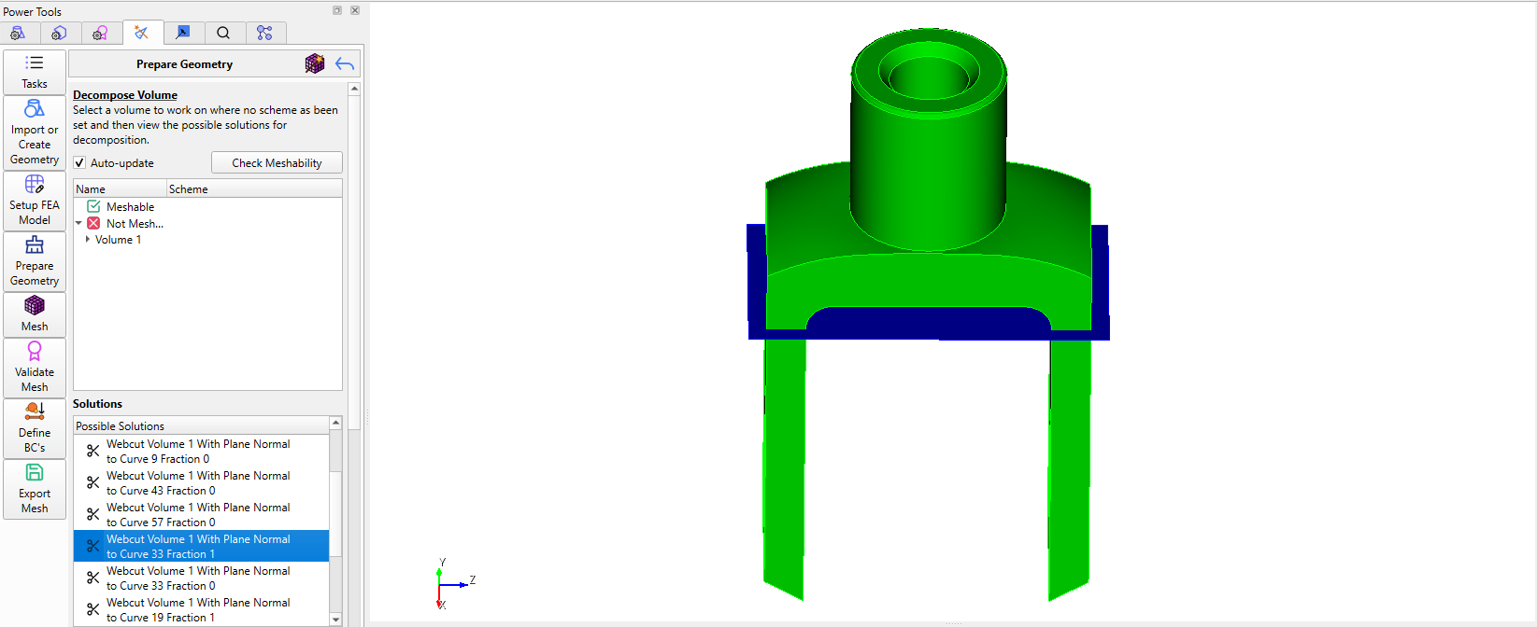

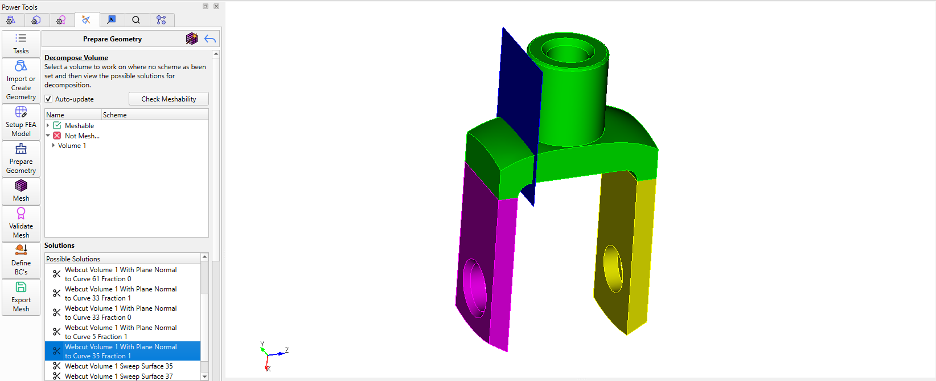

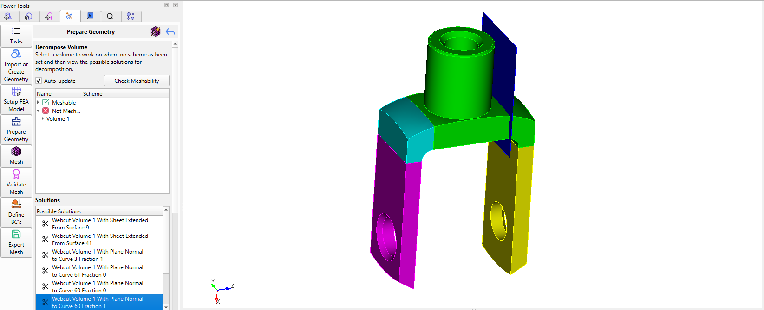

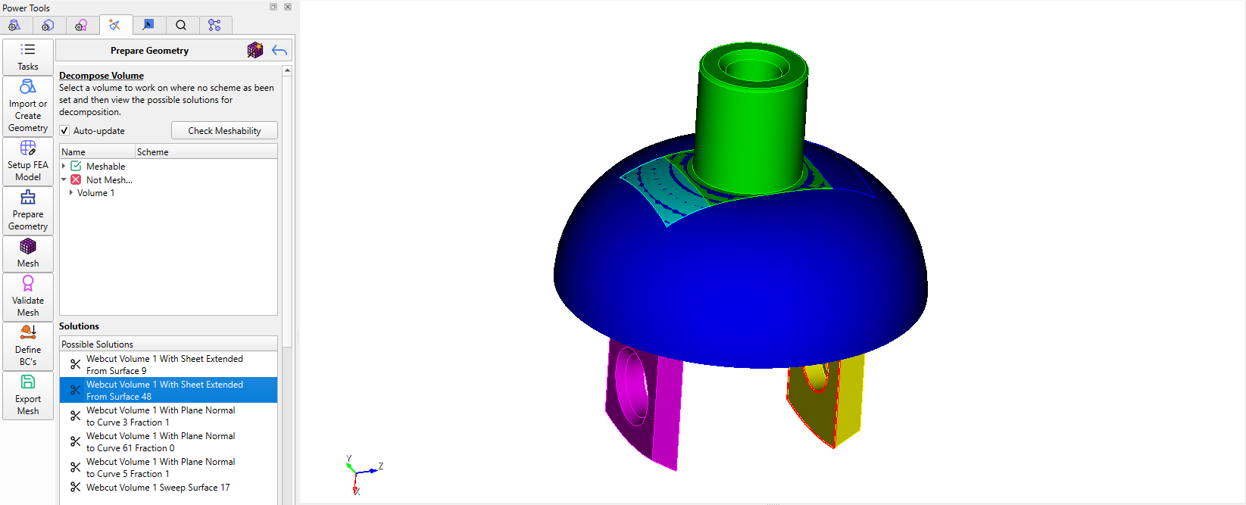

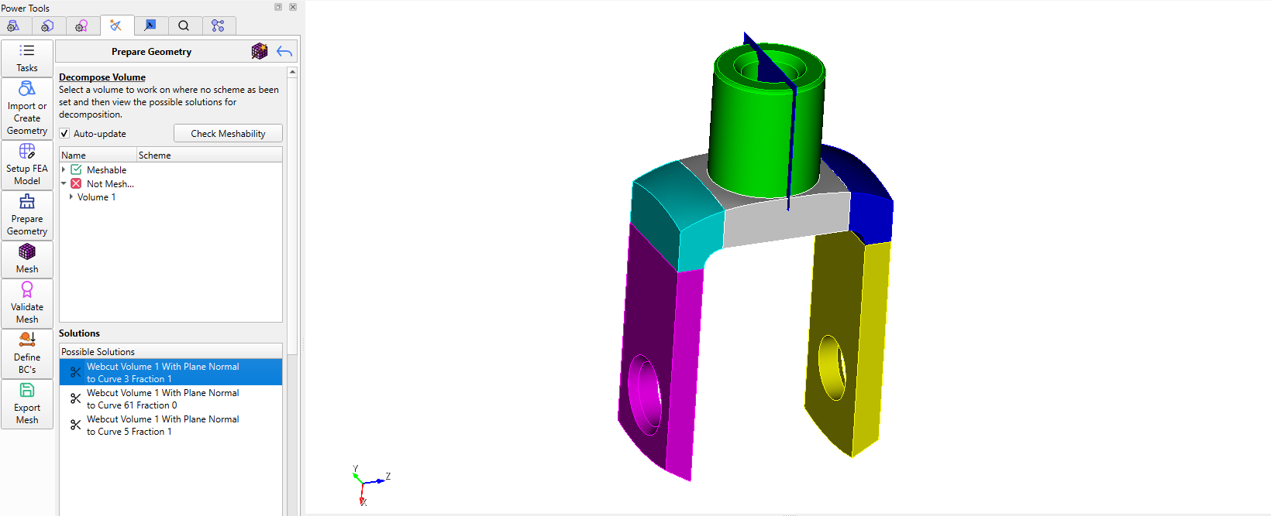

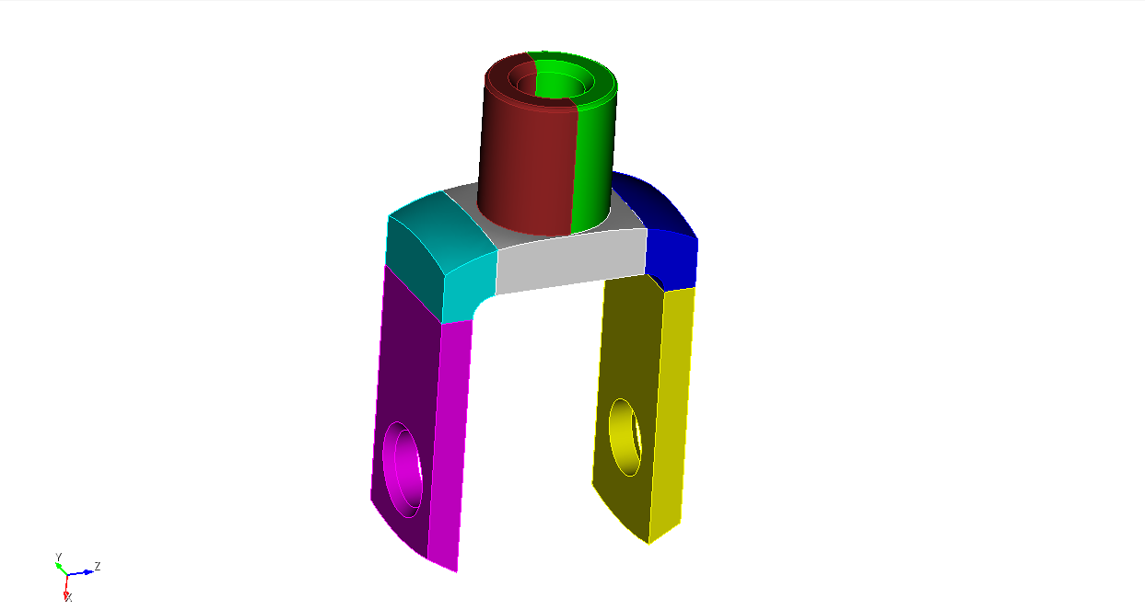

Step 8: Mesh the Geometry
After the webcut solutions have been executed and you have returned to the main ITEM Wizard page, select Mesh the geometry.
In the volume list box, type all. This tells Cubit to mesh all of the volumes in the model instead of only selecting one section.
Run the mesh operation. Cubit will generate the mesh for the full part. Once the mesh is created, scroll down and click Done.
Checkpoint:
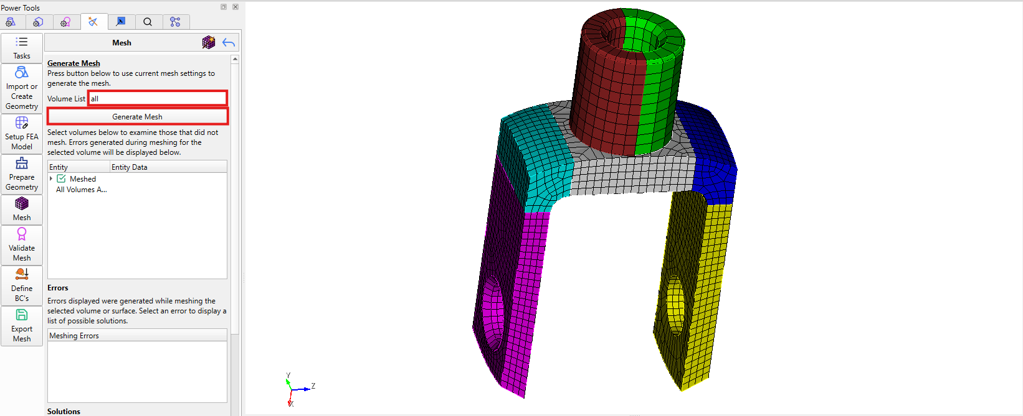
The full model should now be meshed. You should be able to see the mesh lines across the part in the graphics window. The next step will be validating the mesh quality.

Step 9: Define the Mesh Quality Metric
After the model has been meshed, return to the main ITEM Wizard page and select Validate the mesh.
Open Define quality metrics. From the available metrics dropdown, select Scaled Jacobian. Set the minimum value to 0.01 and the maximum value to 2.
Once the Scaled Jacobian limits are set, scroll down and click Done.
Checkpoint:
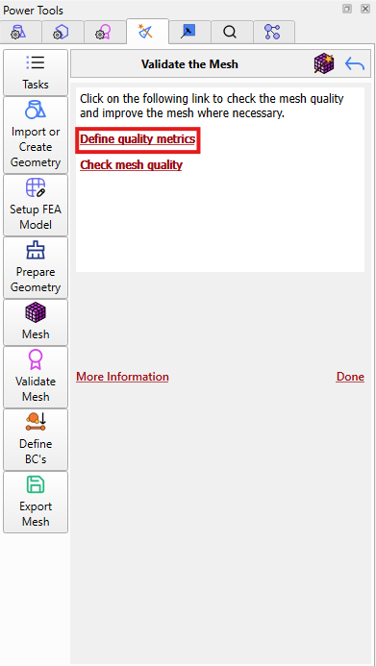
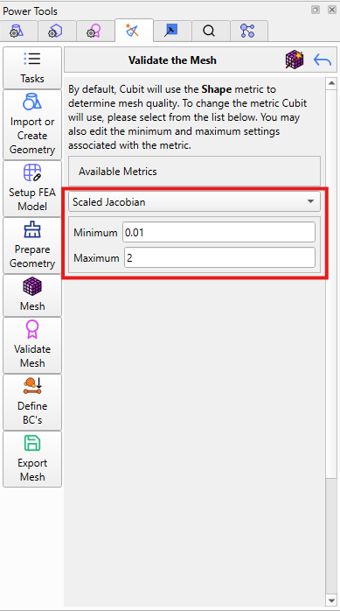
The mesh quality metric should now be set to Scaled Jacobian with a minimum of 0.01 and a maximum of 2. The next step will be checking the mesh quality for all volumes.

Step 10: Check the Mesh Quality
After setting the Scaled Jacobian limits and clicking Done, stay in the Validate the mesh section and open Check mesh quality.
In the volume list box, type all. This tells Cubit to check the mesh quality for every volume in the model.
Run the quality check. Cubit will evaluate the mesh using the Scaled Jacobian settings from the previous step. Review the results to make sure the mesh does not contain bad elements.
Once the check is complete, scroll down and click Done.
Checkpoint:
The mesh quality check should be complete for all volumes. If the results do not show any failed elements, the part has been successfully meshed and validated.
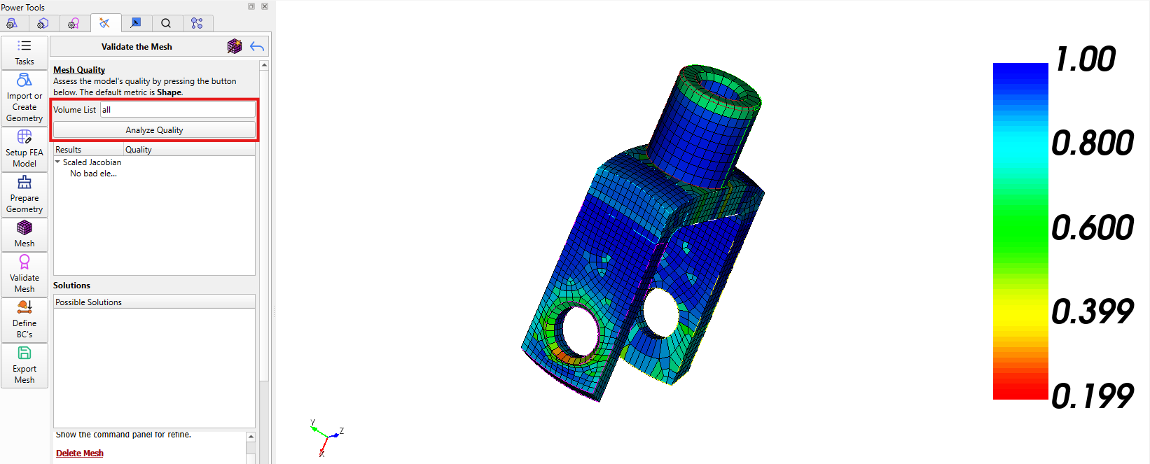

Step 11: Review the Final Mesh Results
After running Check mesh quality, review the results shown by Cubit. The goal is to confirm that the mesh passes the Scaled Jacobian limits that were set in the previous step.
If the mesh quality check does not show any failed elements, the part has been successfully meshed and validated. At this point, the ITEM Wizard workflow is complete.
If Cubit does show failed elements, review the problem areas before finishing. You may need to go back and adjust the geometry, webcuts, or mesh settings before checking the mesh quality again.
Checkpoint:
The mesh should be complete, visible on the full model, and validated with the Scaled Jacobian quality metric.

